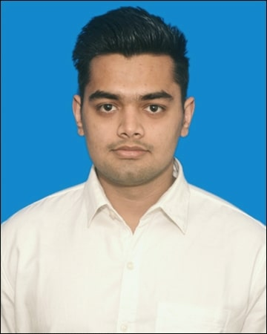

[**ROHIT**](https://www.resumenerd.com/contact/edit)

**Address : Asaudha, Jhajjar, Haryana (124505)**

**Contact :** [**21606rohit@gmail.com**](mailto:21606rohit@gmail.com) **, 7056029215**

# [**SUMMARY**](https://www.resumenerd.com/summary/edit)

[Currently student working toward my B.Tech in CSE and looking for an opportunity to begin my career in the field. Identifying and quickly closing any knowledge gaps to offer value to my employer and team.](https://www.resumenerd.com/summary/edit)

[I am a reliable candidate ready to take on challenges in a position using problem-solving and task prioritization skills to help team succeed.](https://www.resumenerd.com/summary/edit)

# SKILLS

|  |  |  |
| --- | --- | --- |
| Task prioritization  Time management | Coordination  Microsoft Word | Written communication  Java |
| HTML, CSS and Javascript | My SQL | Spring Framework |

[**EDUCATION**](https://www.resumenerd.com/education-overview/edit)

* [March 2015 : **10th**](https://www.resumenerd.com/education-overview/edit)

[Govt. Sr. Sec School, Asaudha,](https://www.resumenerd.com/education-overview/edit) Jhajjar [Scored 82 percentage with general subjects.](https://www.resumenerd.com/education-overview/edit)

* [March 2017 :**12th**](https://www.resumenerd.com/education-overview/edit)

[Govt. Sr. Sec School Asaudha, , J](https://www.resumenerd.com/education-overview/edit)hajjar

[Scored 80.8 percentage with main subjects PCM.](https://www.resumenerd.com/education-overview/edit)

* [July 2022 : **B.Tech**](https://www.resumenerd.com/education-overview/edit) **in CSE stream**

[UIET, Maharshi Dayanand University, Rohtak, Haryana Average percentage is about 70.](https://www.resumenerd.com/education-overview/edit)

* [December 2021 : **Web Development Course**](https://www.resumenerd.com/education-overview/edit)on VERZEO

[Remote, India](https://www.resumenerd.com/education-overview/edit)

[The course was MySQL With Spring Boot .You can check](https://www.resumenerd.com/education-overview/edit) my certificate on these links :

[https://github.com/hellFlames/Certificates/blob/main/Spring-boot%20Certificate%203484281096.jpg](https://github.com/hellFlames/Certificates/blob/main/Spring-boot Certificate 3484281096.jpg)

[https://github.com/hellFlames/Certificates/blob/main/Spring-boot%20Certificate%204012947960.jpg](https://github.com/hellFlames/Certificates/blob/main/Spring-boot Certificate 4012947960.jpg)

# **PROJECTS**

* OneNow : A digital Library.

Live link : https://onenow.herokuapp.com/

# [**H**](https://www.resumenerd.com/additional-section/edit/OTHR/7)**OBBIES**

* [Painting](https://www.resumenerd.com/additional-section/edit/OTHR/7)
* [Playing Football](https://www.resumenerd.com/additional-section/edit/OTHR/7)
* [Photography.](https://www.resumenerd.com/additional-section/edit/OTHR/7)